**Project Planning Phase**

**Project Planning Template (Product Backlog, Sprint Planning, Stories, Story points)**

|  |  |
| --- | --- |
| Date | 23 March 2025 |
| Team ID | SWTID1743689974 |
| Project Name | Book Store |
| Maximum Marks | 5 Marks |

**Product Backlog, Sprint Schedule, and Estimation (4 Marks)**

|  |  |  |  |  |  |  |
| --- | --- | --- | --- | --- | --- | --- |
| **Sprint** | **Functional Requirement (Epic)** | **User Story Number** | **User Story / Task** | **Story Points** | **Priority** | **Team Members** |
| Sprint-1 | Registration | USN-1 | As a user, I can register by entering my email, password, and confirming my password. | 2 | High | **Simar** |
| Sprint-1 | Confirmation | USN-2 | As a user, I will receive a confirmation email once I register. | 1 | High | **Simar** |
| Sprint-2 | Registration | USN-3 | As a user, I can register using Facebook. | 2 | Low | **Simar** |
| Sprint-1 | Registration | USN-4 | As a user, I can register using Gmail. | 2 | Medium | **Simar** |
| Sprint-1 | Login | USN-5 | As a user, I can log in using email and password. | 1 | High | **Aryan** |
| Sprint-1 | Dashboard Setup | USN-6 | As a user, I can view a basic homepage/dashboard UI after login. | 2 | High | **Aryan** |
| Sprint-1 | Wishlist Functionality | USN-7 | As a buyer, I can add/remove books from my wishlist. | 3 | Medium | **Atharva** |
| Sprint-1 | Cart Functionality | USN-8 | As a buyer, I can add/remove books from my cart. | 3 | Medium | **Atharva** |
| Sprint-2 | Genre Filtering | USN-9 | As a user, I can filter books based on genre selection. | 3 | High | **Yash** |
| Sprint-2 | Top Sellers Section | USN-10 | As a user, I can view a list of top-selling books. | 3 | High | **Yash** |
| Sprint-2 | News Section | USN-11 | As a user, I can view news related to books fetched from external API. | 2 | Medium | **Aryan** |
| Sprint-2 | Recommended Books Section | USN-12 | As a user, I can view book recommendations on homepage. | 3 | High | **Atharva** |

**Total Story Points: Sprint-1 = 14, Sprint-2 = 13**

**Project Tracker, Velocity & Burndown Chart: (4 Marks)**

|  |  |  |  |  |  |  |
| --- | --- | --- | --- | --- | --- | --- |
| **Sprint** | **Total Story Points** | **Duration** | **Sprint Start Date** | **Sprint End Date (Planned)** | **Story Points Completed** | **Sprint Release Date (Actual)** |
| **Sprint-1** | **14** | **6 Days** | **24 Oct 2022** | **29 Oct 2022** | **14** | **29 Oct 2022** |
| **Sprint-2** | **13** | **6 Days** | **31 Oct 2022** | **05 Nov 2022** | **13** | **05 Nov 2022** |
| **Sprint-3** | **20** | **6 Days** | **07 Nov 2022** | **12 Nov 2022** | **TBD** | **TBD** |
| **Sprint-4** | **20** | **6 Days** | **14 Nov 2022** | **19 Nov 2022** | **TBD** | **TBD** |

**Velocity :**

* Total Story Points Completed (Sprint 1 + 2) = 14 + 13 = 27
* Total Sprints Completed = 2
* Velocity per Sprint = 27 / 2 = 13.5
* Average Velocity per Day = 13.5 / 6 ≈ 2.25 Story Points/day

**Burndown Chart:**

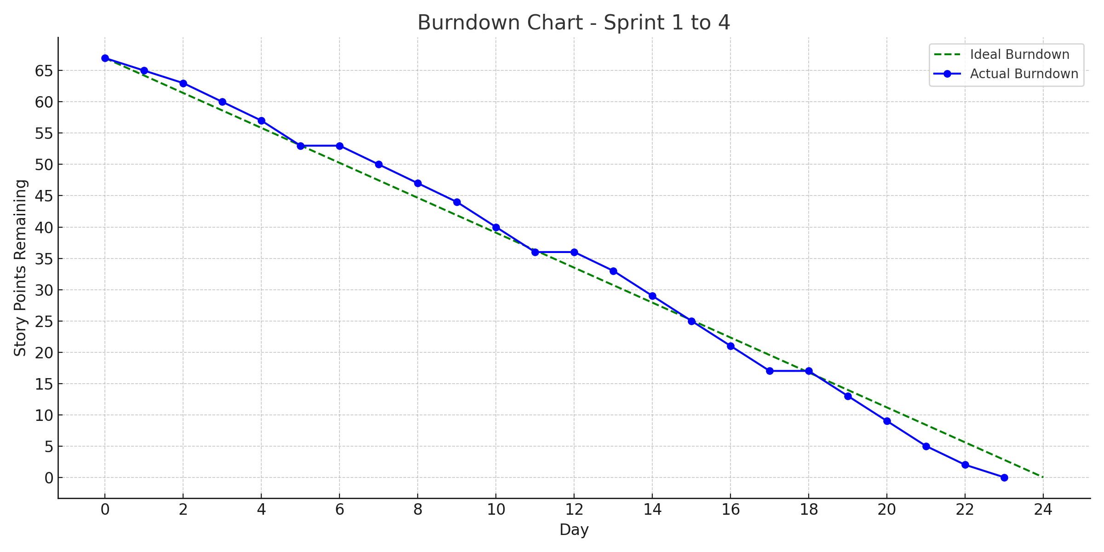A burn down chart is a graphical representation of work left to do versus time. It is often used in agile[software development](https://www.visual-paradigm.com/scrum/what-is-agile-software-development/) methodologies such as [Scrum](https://www.visual-paradigm.com/scrum/scrum-in-3-minutes/). However, burn down charts can be applied to any project containing measurable progress over time.

**Reference:**

[**https://www.atlassian.com/agile/project-management**](https://www.atlassian.com/agile/project-management)

[**https://www.atlassian.com/agile/tutorials/how-to-do-scrum-with-jira-software**](https://www.atlassian.com/agile/tutorials/how-to-do-scrum-with-jira-software)

[**https://www.atlassian.com/agile/tutorials/epics**](https://www.atlassian.com/agile/tutorials/epics)

[**https://www.atlassian.com/agile/tutorials/sprints**](https://www.atlassian.com/agile/tutorials/sprints)

[**https://www.atlassian.com/agile/project-management/estimation**](https://www.atlassian.com/agile/project-management/estimation)

[**https://www.atlassian.com/agile/tutorials/burndown-charts**](https://www.atlassian.com/agile/tutorials/burndown-charts)